Design Document

WLAN Mesh Architecture and Frame Definitions
Architecture.
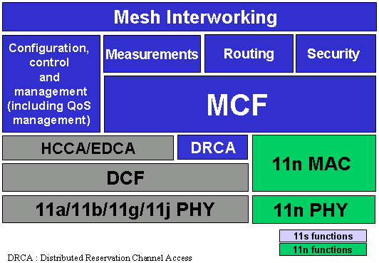

Features

Complete solution addressing all 802.11s Usage Models
Flexible & suitable for Simple / Robust implementations, as well as Sophisticated / High Performance systems

Support for single & multi-radio configurations
Providing an efficient channel usage for regulatory limited domains (e.g. Japan), it leverages at all times on all available RF resources (e.g. channels, radios, etc.)

QoS-efficient
Scalable solution with distributed control achieved with a simple extension from 802.11e to Mesh

Self-Configuring / Ease of manageability
Can be deployed as stand-alone (similarly to ad-hoc mode) or in combination with an infrastructure network (i.e. BSS), providing robust interference mitigation & RF management

Flexible and secure
With authentication and key management procedures using 802.11i concepts, it provides secure key distribution and secure exchange of routing information, supporting distributed or centralized models

Dynamic routing support
QoS, radio & power-efficiency aware routing with WDS four-addressing extension that supports dynamic auto-configuration of MAC-layer data delivery paths for unicast, multicast & broadcast, as well as integrated BSS & WLAN mesh unicast data delivery, with efficient broadcast/multicast transport

Multiple routing algorithms support
Enables multiple routing algorithms for MAC address based forwarding with a simple Hello message for mesh discovery and mesh association, supporting extended mesh discovery

Seamless routing and security integration
Agnostic to radio types, wireless stations or applications, it provides mesh extensions with multi-hop encryption of unicast/multicast data
Secure neighborhood association performed at Beacon or hello time, and multi-hop encryption hop-by-hop authentication with multicast and tunnel support
Optional Knobs for re-keying and replay protection defined, as well as extensions to protect pre-associated traffic with Authentication

Channel access coordination across multiple nodes
To avoid performance degradation and/or meet QoS goals in the multi-hop network
Mesh link peer-to-peer communication coordination
Enable distributed auto-configure wireless mesh architecture

1.2. Support for QoS
Traffic prioritization within WLAN Mesh
Flow control over multi-hop paths
Support for contention resolution mechanism
Load control enhancements for efficient multicasting and broadcasting in a mesh network

Power save support
Power aware scheduling

Efficient RF frequency and spatial reuse
To mitigate performance degradation caused by hidden nodes & exposed nodes
Allows for concurrent transmissions and enhanced capacity

Network scalability
To address different network sizes, network topology, usage models, etc.

PHY Agnostic
Independent to antenna arrangement (i.e. omni, directional antenna or smart antenna), number of radios, channel quality and signal propagation environment

Mesh Routing

HWMP Multi-Radio Supporting
Context.

Mesh Security

Mesh Interworking

